1-Page Summary Report: FarmBurg A/B Test (Microtransaction Pricing)

Problem Statement
Brian (Product Manager, FarmBurg) tested three price points for a small upgrade package: $0.99 (Group A), $1.99 (Group B) and $4.99 (Group C). The business requires a minimum of $1 000 weekly revenue to justify the feature. A naïve Chi-Square test shows the purchase rates differ dramatically, but that test answers the wrong question. The correct decision metric is whether each price produces a purchase rate high enough that expected weekly revenue exceeds the $1 000 hurdle.

Solution Strategy
1. Load the week-long experiment data (n = 4 998, balanced arms) and build the group × purchase contingency table.
2. Run a Chi-Square test of independence (diagnostic only) and confirm rates differ (p ≈ 2.4 × 10⁻³⁵).
3. Convert the $1 000 revenue target into a required purchase rate for each price: 20.2 % ($0.99), 10.1 % ($1.99), 4.0 % ($4.99).
4. Perform one-sided binomial tests (Ha: rate > target) for each arm; recommend the price(s) that clear α = 0.05.
5. Augment with Wilson CIs, observed-vs-target revenue charts, Cramér’s V, pairwise post-hoc tests, and a simulation playground that varies the revenue target / traffic / true rates.

Solution
Observed rates: A 18.97 %, B 10.98 %, C 4.98 %. Only Group C (p = 0.028) is significantly above its revenue-required rate. Observed week revenues were $313 / $364 / $414 — all below $1 000 — yet the statistical claim is about the long-run expectation. Recommendation: charge $4.99.
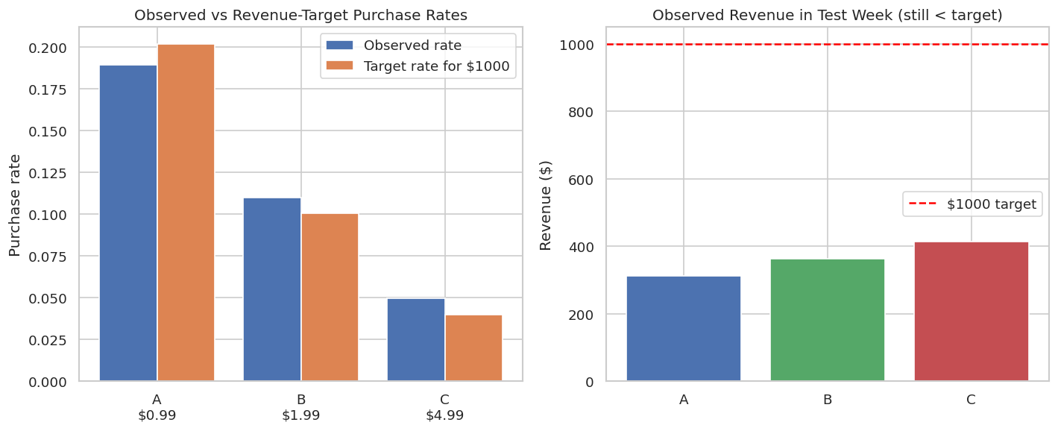
Figure: Observed purchase rates vs. revenue-target rates (left) and observed test-week revenue (right).

Key Takeaways
• Match the statistical test to the business question. A significant Chi-Square only proves rates differ; the revenue hurdle requires a one-sided binomial test against a derived target proportion.
• Higher price can win even with lower conversion. Group C’s 5 % rate still clears the $1 000 bar while the cheaper arms do not.
• Observed single-week revenue may still be below target; the test supports the expectation of future weeks, not a guarantee for the next calendar week.
• Sensitivity simulation is essential. Lowering the target to $400, doubling traffic, or changing the assumed true rate for C all alter which prices clear the hurdle — product managers should explore these scenarios before locking a price.
• Continuous monitoring after launch remains necessary; a sudden drop in the true rate for the $4.99 offer would invalidate the original decision.

